**CSC545:DATABASE SYSTEMS**

PROJECT-5:PORTAL SYSTEM DEVELOPMENT

**INTRODUCTION:**

This system is basically concerned with the pairing of the user in the portal system. Here In order to get paired with the other user , a user should send invitation a person. So, for this operation a user will be provided with his/her username and password where he can access his profile In order to send Invitation. After Invitation is sent, the other user uses his login credentials In order to Accept the Invitation. Once, he accepts the Invitation the Status gets changed from “Unselected” to “Selected”.

**USE CASES:**

|  |  |
| --- | --- |
| Case # | 1 |
| Step 1: primary actor and goal | View all names of other users and send invitations up to 5 people. |
| Step 2: main scenario (cannot be simpler, always ok, happily ends) | 1. Select up to 5 users. 2. Send out the invitations. 3. Repeat the above until invitation is sent to 5 people successfully   https://documents.lucidchart.com/documents/6f602828-166b-42fb-849a-92a88b0c1398/pages/6eyeccbIQRks?a=1664&x=183&y=165&w=908&h=241&store=1&accept=image%2F*&auth=LCA%20e4b41e5cb1da6d99e59a5953bd77c87700bc5b25-ts%3D1557182806 |
| Step 3: Failures | In step 1 of main scenario, information can be mismatched –  **When** the invitation is sent to   1. Different Username 2. More than 5 users 3. Invalid Users   In step 1 of main scenario, the user is unauthorized and tried to view the information beyond his/her access right –  **When**   1. Identity of this user is incorrect. |
| Step 4: alternative scenarios (from exceptions in the above) | a-b. The existence of the user must be confirmed first by checking the committed status, and selection only of 5 or less users. If the process fails with any reason, the view access must be denied. Process go back to step 1 of main scenario.  c. Login process is needed before step 1 of main scenario, in order for the user to obtain the right data access. After that, step 1 can be executed. |

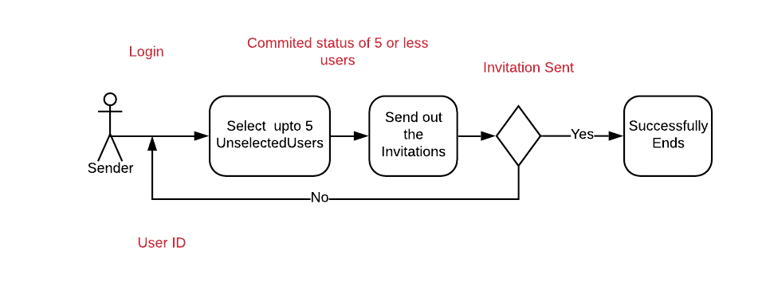



|  |  |
| --- | --- |
| Case # | 2 |
| Step 1: primary actor and goal | Receiver views and Accepts one of the invitations and if these two users are paired then these two users will be removed from the list and status changed to “selected”. |
| Step 2: main scenario (cannot be simpler, always ok, happily ends) | 1. Accept one of the invitations 2. See if these two users are paired 3. If paired, then remove these two users from the list and the status changed to “selected”; if not, remain “unselected”.   https://documents.lucidchart.com/documents/6f602828-166b-42fb-849a-92a88b0c1398/pages/0_0?a=622&x=432&y=151&w=993&h=198&store=1&accept=image%2F*&auth=LCA%20847b9a038076750b5df60d28435484d0e1c4bcfd-ts%3D1557082836 |
| Step 3: Failures | In step 1 of main scenario, it can be wrong  **When** users   1. Identity of this user is incorrect.   In step 2 of main scenario, it can be wrong  **When** users   1. User can choose more than 1 invitations 2. The input for the choice is incorrect   In step 3 of main scenario, it can be wrong  **When**   1. Status is not changed correctly 2. The input for reselect is incorrect   In step 4 of main scenario, it can be wrong  **When**  Paired users are not removed from the list |
| Step 4: alternative scenarios (from exceptions in the above) | 1. Design the system that the user only can input one Invitation to accept. 2. Provide an alert that asks user to enter the correct Information 3. Check the System for status 4. Make sure the remove function and check the system for User’s status |

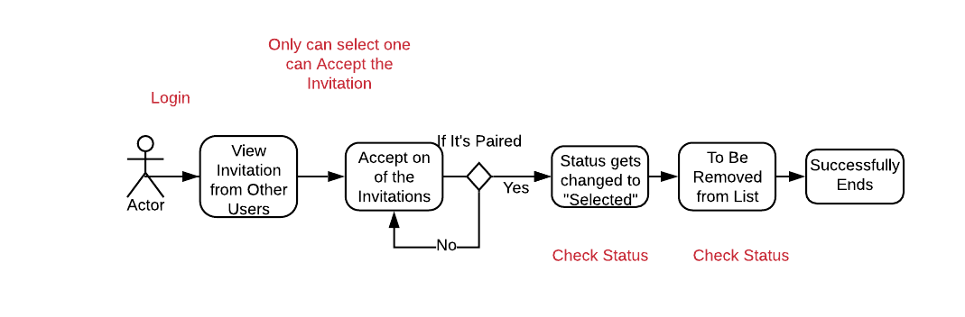



|  |  |
| --- | --- |
| Case # | 4 |
| Step 1: primary actor and goal | Committed users sees partner information |
| Step 2: main scenario | 1. Committed user sees his partner information   https://documents.lucidchart.com/documents/6f602828-166b-42fb-849a-92a88b0c1398/pages/0_0?a=914&x=266&y=173&w=685&h=154&store=1&accept=image%2F*&auth=LCA%20daa2b06f594017fc48e95bc750579ca0d832fe80-ts%3D1557082836 |
| Step 3: Failures | In step 1, the update could be wrong –  **When**   1. User sees different information other than that of the partner. 2. Invalid Login Credentials |
| Step 4: alternative scenario | 1. Login process is needed as step 1 of UC4. |

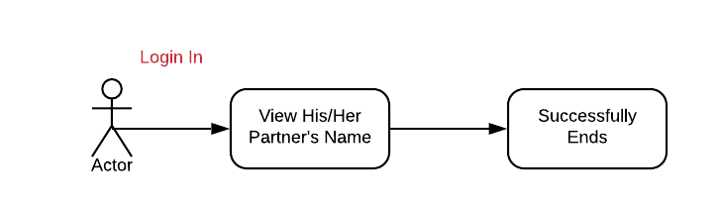



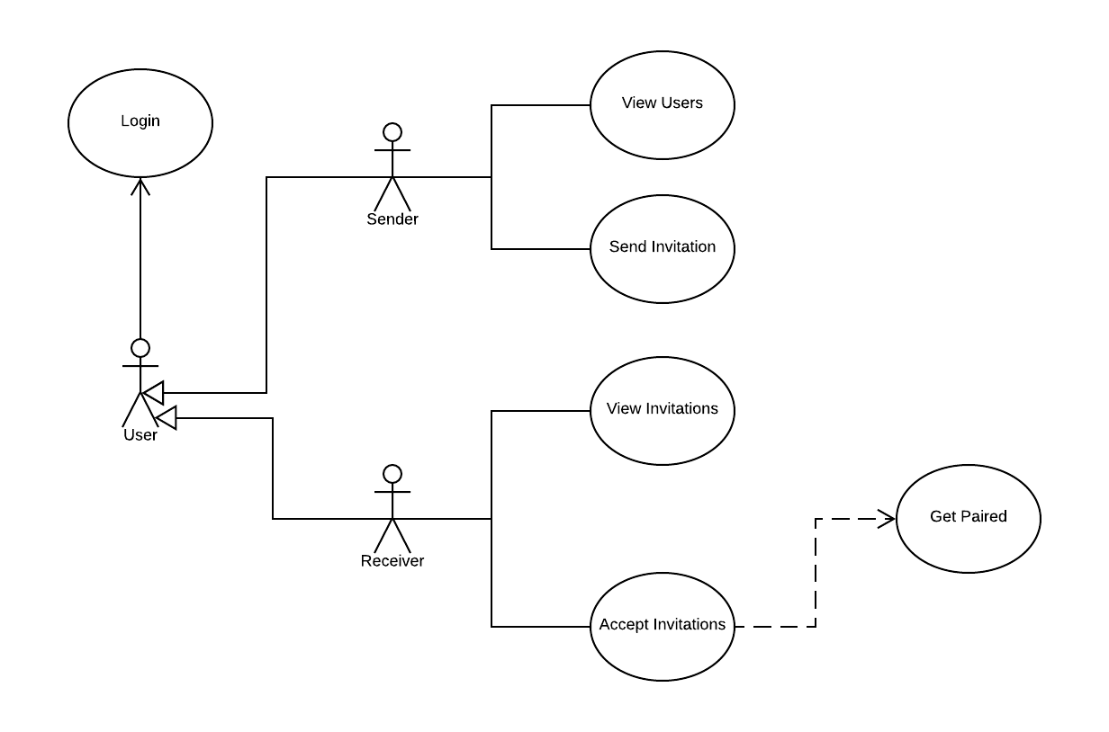

**UML DIAGRAM:**

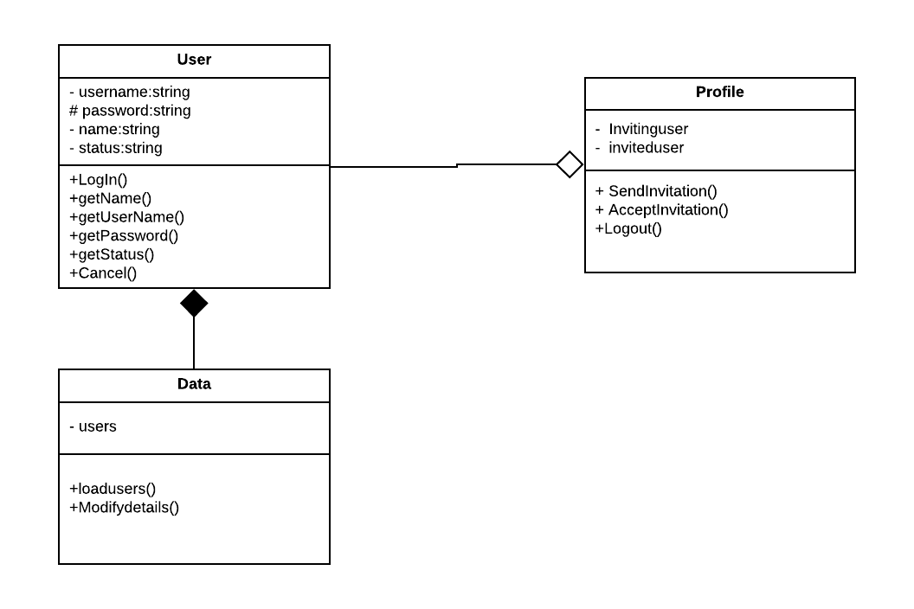

|  |  |
| --- | --- |
| Information covered | Object/Class |
| User name (UC1 & UC2 & UC3) | Unselected User |
| User login password (UC2) |
| User Status (UC1) |
| Send Invitation(UC2) |
| Accept Invitation(UC3) |  |
| Partner’s Name | Selected User |